参看文档，有些命令参看redis单机版：

<https://www.cnblogs.com/lihaoyang/p/6906444.html?tdsourcetag=s_pctim_aiomsg>

可以参看window 集群安装

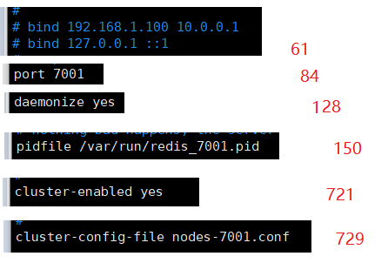

如果是2台服务器分别三个redis，开启远程，

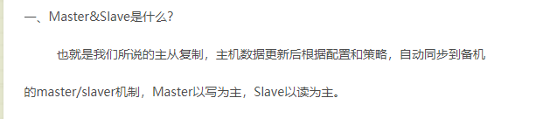

用公网地址启动

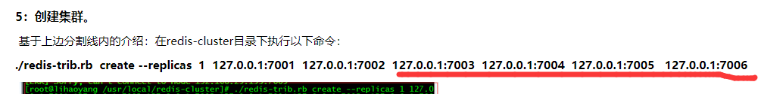

随机确定3个主节点和备用节点

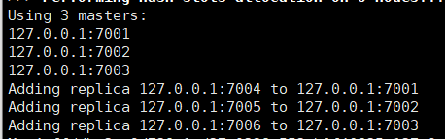

# 问题

## Invalid configuration for cluster creation

https://blog.csdn.net/zhou_438/article/details/84712197

## [ERR] Node is not empty. Either the node already knows other nodes (check with C

https://blog.csdn.net/u014756827/article/details/52061987

